Assignment:- 9
Case-Study
Digital Electronics and Microprocessor Applications in Smart Home Automation Systems

Introduction:
Modern homes are evolving into smart environments, where everyday appliances and systems are automated for convenience, security, and energy efficiency. Smart home automation integrates digital electronics, microprocessors, communication systems, and sensors to monitor and control household functions such as lighting, temperature, door locks, and appliances.
The foundation of such systems lies in digital logic circuits and microprocessor-based control, which allow real-time data processing, decision-making, and user interaction.
In this case study, we explore how digital fundamentals, combinational and sequential circuits, and microprocessor architecture together form the backbone of a smart home automation system.

System Overview:
A smart home automation system generally consists of the following components:
- Sensors: Motion sensors, temperature sensors, gas sensors, and light sensors.
- Microcontroller/Microprocessor: The brain of the system that processes signals and executes decisions.
- Actuators: Devices that perform actions (switch lights, fans, locks).
- Communication Interface: Wi-Fi, Bluetooth, or Zigbee for remote control.
- User Interface: Mobile app or web dashboard for manual control and monitoring.
When a sensor detects an event (e.g., motion in a room), it sends a binary signal (1 for motion, 0 for no motion) to the processor. The processor applies logic functions and executes control operations such as turning lights ON or adjusting temperature.

Digital Logic in Smart Systems:
All data processing within a smart home system happens in binary form. The microcontroller uses digital circuits such as AND, OR, and NOT gates to process logic.
- Example:
If motion is detected (M=1) and light level is low (L=0), the circuit output (Light Control) = M AND (NOT L) = 1 → Turns ON light.
Such logical functions are often simplified using Karnaugh Maps (K-maps) during system design to minimize the number of gates and optimize the circuit’s performance.
Don’t Care Conditions are used when certain sensor combinations are irrelevant (for example, daylight brightness when the house is unoccupied).
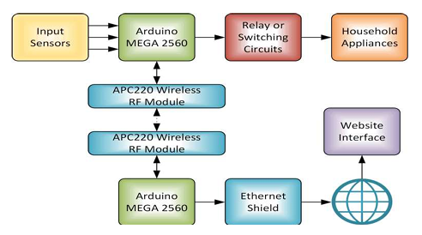

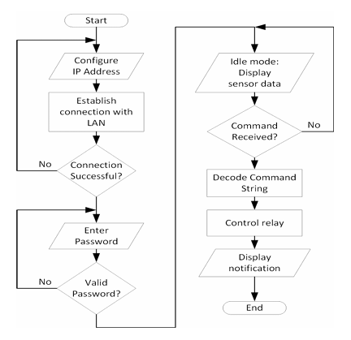

Processing and Control:
At the heart of the system lies a microprocessor or microcontroller (for example, an ARM Cortex or an 8086-based embedded controller). It executes instructions that handle:
- Data transfer between memory and input/output ports.
- Arithmetic/logical operations for calculations (like temperature control or energy usage).
- Branching instructions to make decisions (“if motion detected → jump to light control routine”).
- Interrupts to handle high-priority tasks (like smoke alarms overriding normal operation).
The concept of interrupts, vector tables, and priority handling (from Unit 6) ensures that urgent signals such as fire or gas detection are processed immediately, ensuring safety.
Timers (like 8253/8254) and counters manage periodic tasks, e.g., checking sensors every few milliseconds or turning off a fan after a set time.

Sequential Operations and Memory Control:
Smart systems use flip-flops and counters to maintain states — whether a device is currently ON or OFF, or to count how long an event has persisted.
A JK or D flip-flop can act as a 1-bit memory to remember the state of a switch.
Sequential logic allows features like:
- Timed lighting systems.
- Door locking mechanisms that require specific sequences.
- Security systems that count failed password attempts before triggering an alarm.
These circuits form the building blocks of finite state machines (FSMs) used in automation control logic.

Advanced Microprocessor Features:
Modern smart home hubs are built on superscalar microprocessors (like the Pentium or ARM families) that support:
- Pipelining: Executes multiple instructions simultaneously, increasing speed.
- Branch prediction: Anticipates decisions to reduce delay.
- Cache memory: Stores frequently used instructions for faster processing.
- Floating-point units (FPUs): Handle complex sensor data, such as analog voltage readings from environment sensors.
These features make automation systems efficient and real-time responsive, capable of handling multiple devices simultaneously.

Role of Interrupts and Timer:
The automation system continuously monitors sensor inputs using interrupts.
- Hardware Interrupts: Generated by sensors (motion detected).
- Software Interrupts: Triggered by the running application for background tasks (e.g., periodic status updates).
- Timer Interrupts: Used to perform actions after fixed intervals, like turning off the light after 5 minutes.
Priority interrupt controllers (like 8259) ensure that safety-related interrupts (like fire or gas detection) are handled before routine events.

Benefits and Real-Life Impact:
Using digital and microprocessor-based design offers:
- Energy efficiency: Intelligent decision-making reduces power waste.
- Security: Real-time alerts for intrusion or fire.
- Convenience: Hands-free automation via smartphone or voice assistants.
- Scalability: Easy to expand by adding new devices and sensors.
These systems showcase how fundamental electronic principles translate into practical, everyday technology that improves quality of life.

Conclusion:
The Smart Home Automation System is a powerful example of how digital electronics and microprocessor architectures combine to create intelligent, responsive, and efficient systems.
Concepts such as binary logic, combinational circuits, sequential logic, microprocessor addressing modes, interrupts, and timing control work together to form the core of modern embedded applications.
From simple light control circuits to complex multi-core automation processors, the knowledge gained from these six units is directly applied to shaping the future of smart living environments.

